**A) KPI’S:**-  
  
**1) TOTAL REVENUE**

select sum(total_price)

as Total_Revenue

from pizza_sales;  
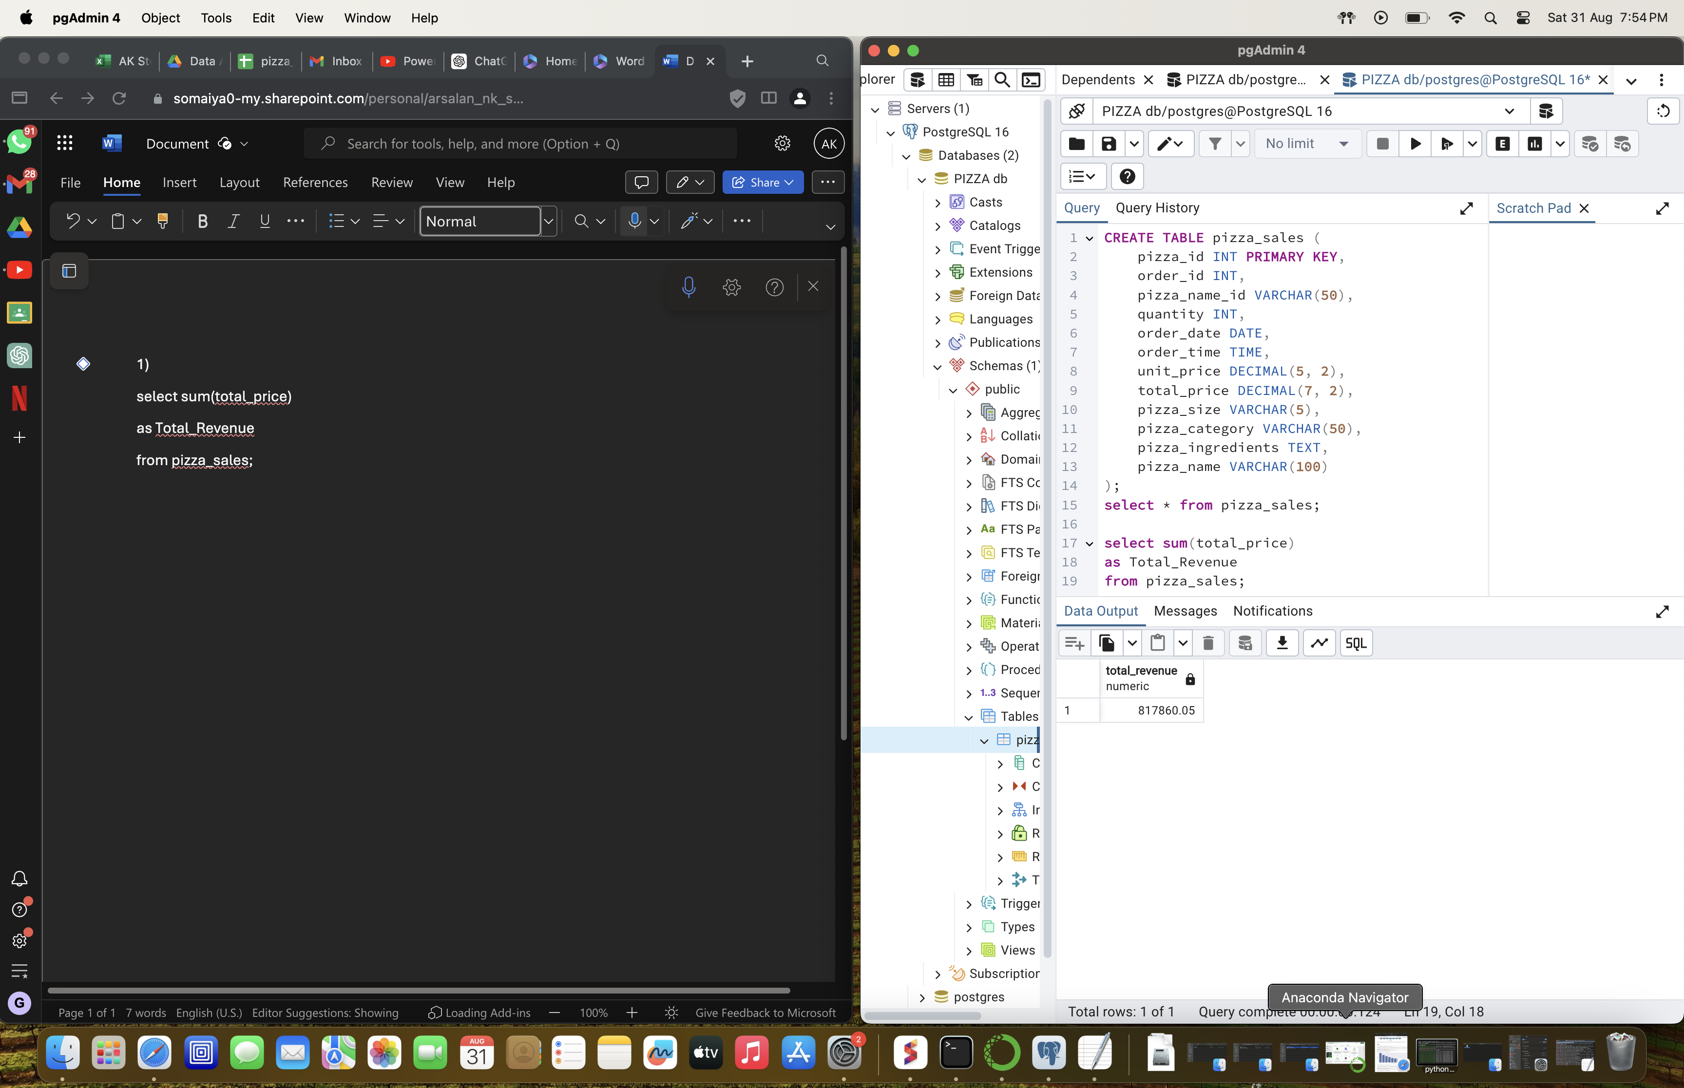

**2)AVG ORDER VALUE**

select

sum(total_price)/count (distinct order_id)

as Avg_order_value

from pizza_sales;

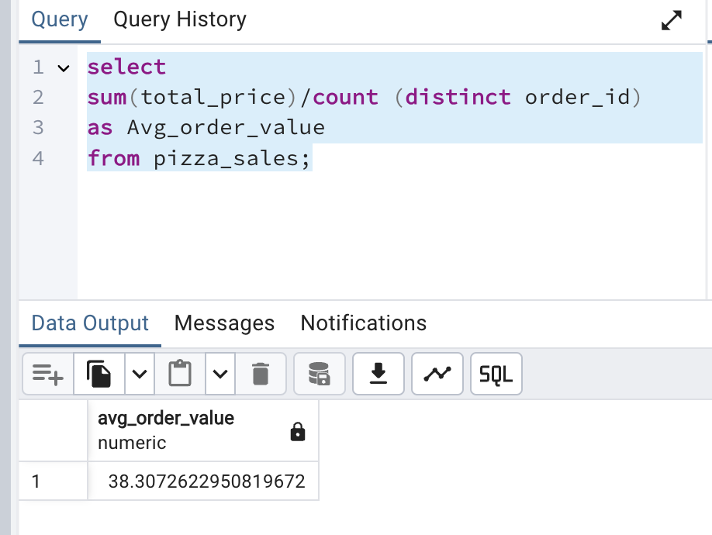

**3)Total pizza sold**

select SUM(quantity) as total_pizzza_sold from pizza_sales;

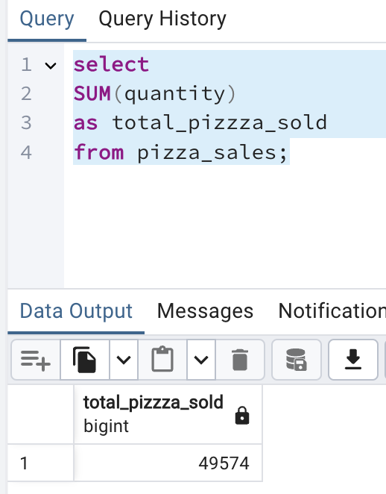

**4)Total orders**  
select count(distinct order_id)as total_order

from pizza_sales;

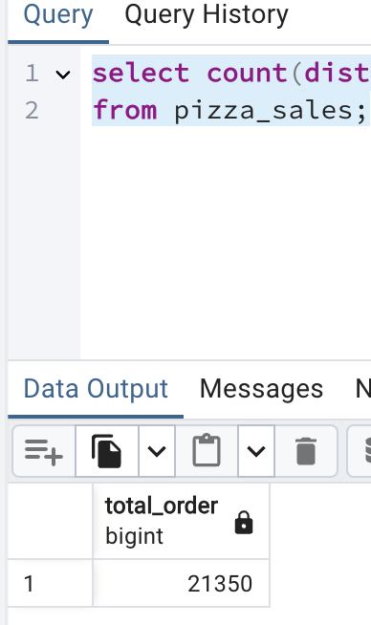

**5) Avg pizza per order**   
select cast(cast(sum(quantity)as decimal (10,2)) / cast(count(distinct order_id) as decimal (10,2)) as decimal(10,2)) as Avg_pizza_per_order from pizza_sales;

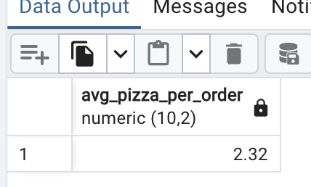

**B)CHART REQUIREMENTS**

**1)DAILY TREND FOR TOTAL ORDERS**

SELECT

TO_CHAR(order_date, 'Day') AS order_day,

COUNT(DISTINCT order_id) AS total_orders

FROM

pizza_sales

GROUP BY

TO_CHAR(order_date, 'Day'), EXTRACT(DOW FROM order_date)

ORDER BY

EXTRACT(DOW FROM order_date);

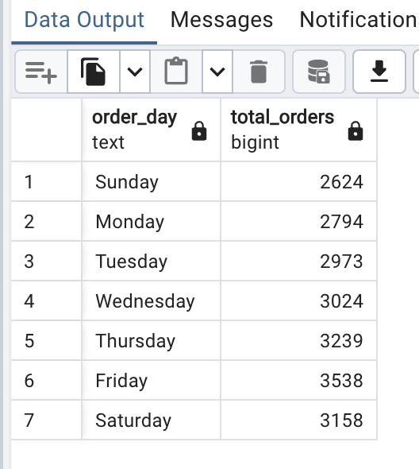

**2)MONTHLY TREND OF TOTAL ORDERS**  
**SELECT**

**TO_CHAR(order_date, 'MONTH') AS order_day, COUNT(DISTINCT order_id) AS total_orders**

**FROM pizza_sales**

**GROUP BY**

**TO_CHAR(order_date, 'MONTH'), EXTRACT(MONTH FROM order_date)**

**ORDER BY EXTRACT(MONTH FROM order_date);**

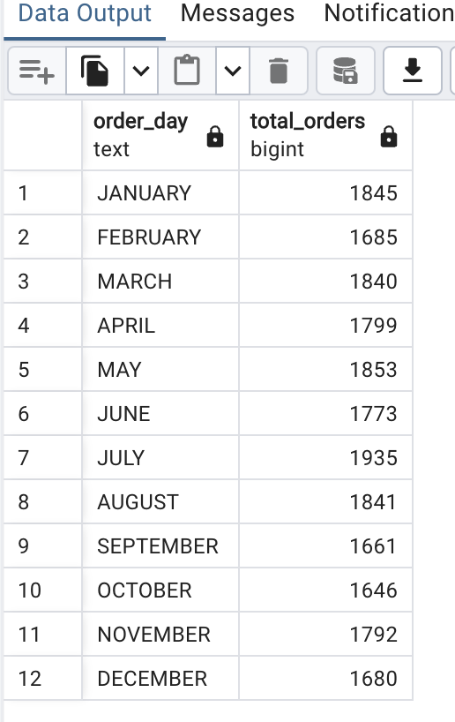

3)PERCENTAGE OF SALES BY PIZZA CATEGORY

**select pizza_category,sum(total_price)*100/**

**(select sum(total_price) from pizza_sales) as pts**

**from pizza_sales**

**group by pizza_category**

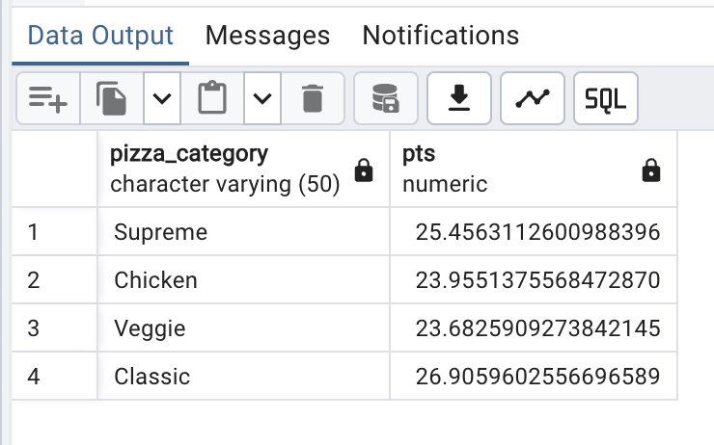

**4) BY PIZZA SIZE**

**SELECT pizza_size,**

**cast(SUM(total_price) * 100.0 /**

**(SELECT SUM(total_price)**

**FROM pizza_sales)as decimal(10,2)) AS pts**

**FROM pizza_sales**

**GROUP BY pizza_size**

**order by pts desc;**

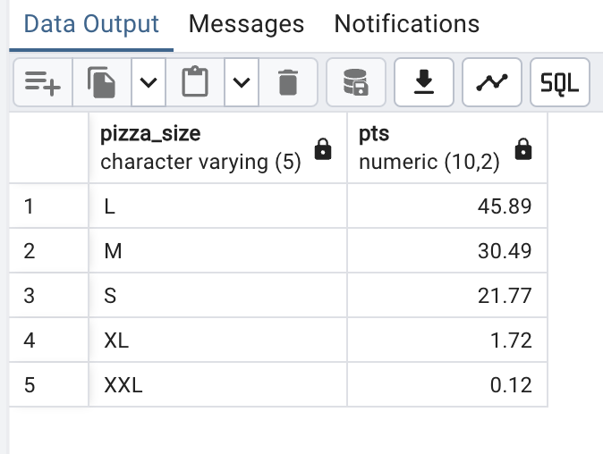

**5)TOTAL PIZZA SOLD BY PIZZA CATEGORY**

**SELECT pizza_category,sum(quantity)as total_quant**

**FROM pizza_sales**

**GROUP BY pizza_category;**

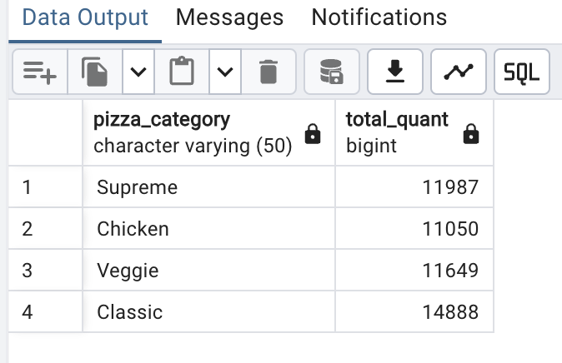

**6)TOP 5 BESTSELLERS BY REVENUE,QUANTITY,TOTAL ORDERS**

**By revenue**

**SELECT pizza_name, SUM(total_price) AS Total_Revenue**

**FROM pizza_sales**

**GROUP BY pizza_name**

**ORDER BY Total_Revenue DESC**

**LIMIT 5;**

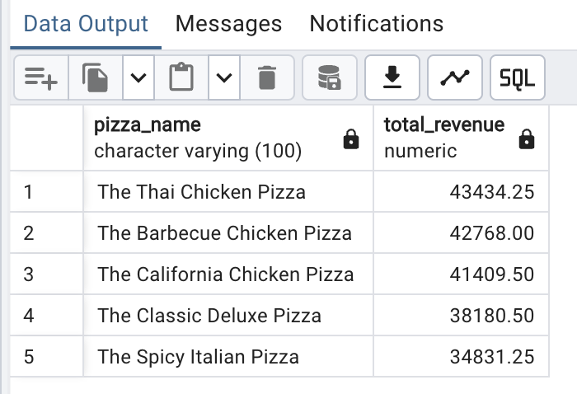

**By quantity**

**SELECT pizza_name, SUM(quantity) AS Total_quantity**

**FROM pizza_sales**

**GROUP BY pizza_name**

**ORDER BY Total_quantity DESC**

**LIMIT 5;**

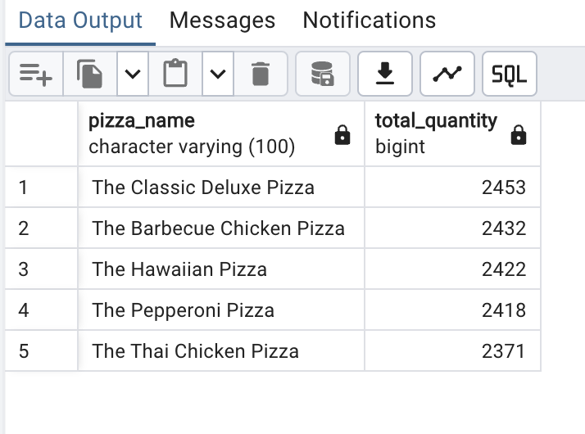

**Total orders**  
**SELECT pizza_name,COUNT(DISTINCT order_id) AS Total_Orders**

**FROM pizza_sales**

**GROUP BY pizza_name**

**ORDER BY Total_orders DESC**

**LIMIT 5;**

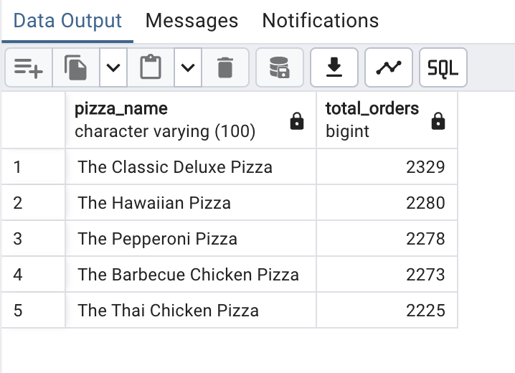

**7)BOTTOM 5**

**Total order**

**SELECT pizza_name,COUNT(DISTINCT order_id) AS Total_Orders**

**FROM pizza_sales**

**GROUP BY pizza_name**

**ORDER BY Total_orders asc**

**LIMIT 5;**

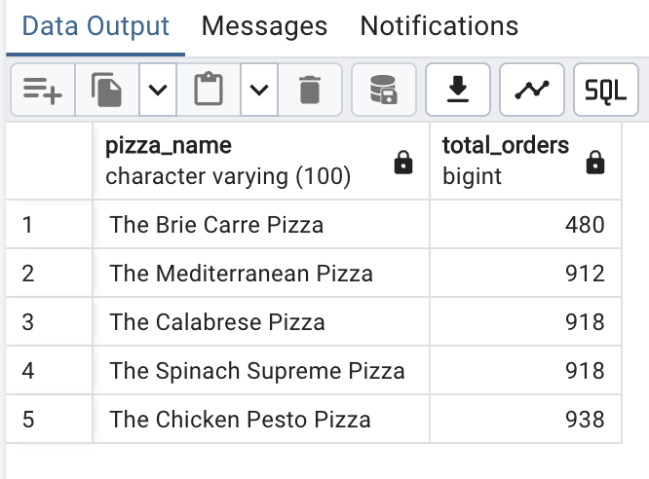

**By quantity**  
**SELECT pizza_name, SUM(quantity) AS Total_quantity**

**FROM pizza_sales**

**GROUP BY pizza_name**

**ORDER BY Total_quantity asc**

**LIMIT 5;**

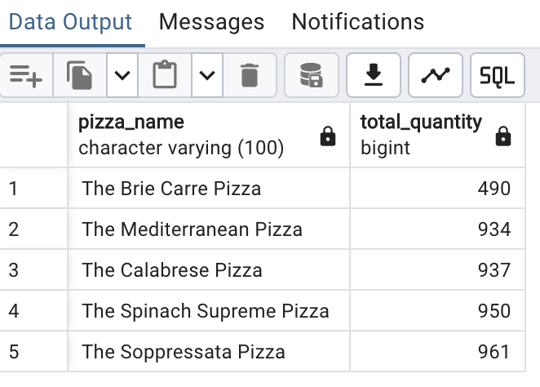

**By revenue**

**SELECT pizza_name, SUM(total_price) AS Total_Revenue**

**FROM pizza_sales**

**GROUP BY pizza_name**

**ORDER BY Total_Revenue asc**

**LIMIT 5;**

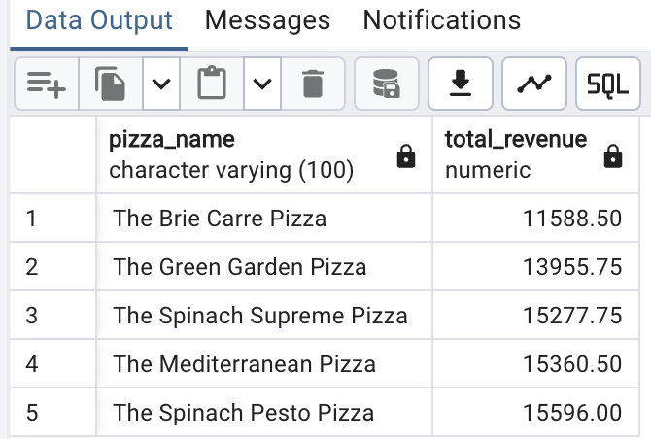

***NOTE***

Want to apply the pizza_category or pizza_size filters to the above queries you can use WHERE clause. Follow some of below examples

SELECT Top 5 pizza_name, COUNT(DISTINCT order_id) AS Total_Orders

FROM pizza_sales

WHERE pizza_category = 'Classic'

GROUP BY pizza_name

ORDER BY Total_Orders ASC